NCI/CBIIT

GreenSheets System

Draft Area Scope

Version 1.0

Document History

Document Location

Ensure that this document is current. Printed documents and locally copied files may become obsolete due to changes to the master document. The source of this document is located in the SVN documentation repository at: ***https://ncisvn.nci.nih.gov/svn/iscs/greensheets/Requirements/Specs/***[Draft Area - Scope.docx](https://ncisvn.nci.nih.gov/svn/iscs/greensheets/Requirements/Specs/GreenSheets%20-%20Scope.docx)

Revision History

[Provide a summary of changes for a new version or revision of this document.]

| Version Number | Revision Date | Author | | Summary of Changes |
| --- | --- | --- | --- | --- |
| 1.0 | 10/25/2016 | G. Tulchinskaya | Initial version | |
|  |  |  |  | |
|  |  |  |  | |

Reference Documents

[Provide a complete list of all documents referenced within, or in the formulation of this document.]

|  | Document Name |
| --- | --- |
|  | <https://ncisvn.nci.nih.gov/svn/iscs/greensheets/Requirements/Meeting%20Minutes/Draft%20area%20_%20meeting%20with%20OGA%20meeting%20minutes.docx> |
|  | <https://ncisvn.nci.nih.gov/svn/iscs/greensheets/Requirements/Specs/GreenSheets%20Redesign%20Project%20Scope.docx> |
|  | <https://i2e-test.nci.nih.gov/documentation/application/GSFB_User_guide.pdf> |
|  | <https://ncisvn.nci.nih.gov/svn/iscs/greensheets/Requirements/Use-cases/View%20and%20Manage%20a%20greensheet%20use-case.doc> |

Key Terms

Please refer to <https://ncisvn.nci.nih.gov/svn/iscs/greensheets/Requirements/Specs/GreenSheets%20Redesign%20Project%20Scope.docx>

[This information may be provided by reference to the eRA Global Glossary (or the project- or system-specific glossary), and in such cases, simply reference those documents and leave the table below blank.]

Table of Contents

1. Document scope 3

2. Business Need Description 3

3. User roles 3

3.1 Before re-design: 3

3.2 Changes for re-design: 4

4. Diagrams 6

5. Overall business flow description 6

5.1 For a user with Author/Approver and/or Draft Administrator role 6

5.1.1 Email to testers 8

5.2 For a Tester 9

6. Accessing review functionality 10

6.1 Flow of events 10

6.2 Mockup 11

6.3 Data elements 11

7. Review and Manage Module functionality 12

7.1 “Review and Manage Module” flow of events 12

7.2 Review and Manage Module screens mockups 12

7.2.1 General mockup for all modules, except Revision 12

7.2.2 “Existing Type/Mechanism combinations with no changes” section mockup 13

7.2.3 Revision module mockup 13

7.1 Review and Test Module Screen Data elements 13

8. Test Greensheet functionality 16

8.1 “Test” flow of events 16

8.2 Review and Test Greensheet Screen mockup 17

8.3 Sub-questions 17

8.4 Review and Test Greensheet Screen Data elements 17

9. Promote or Reject the module functionality 20

10. Import templates from GS Form Builder 21

11. Email Notifications about greensheets module deployment process. 23

# Document scope

[Outline the scope of what has been captured in this version of the document. For example, “This Supplementary Specification document describes the functional and non-functional requirements that span Use cases for the ABC system, Release 4”.]

This document provides functional and non-functional requirements for Draft Area in the GreenSheets System.

# Business Need Description

Form Builder system allows grants administration personnel to directly specify, modify and deploy greensheets questionnaires. Within Form Builder system the questionnaires (forms) are grouped in modules (sets of forms). Export of new forms from Form Builder to Greensheets is always at the level of a Module.



When a new module is exported, all forms are available in the draft area that serves two major purposes:

* Proving ability to test forms before promoting them into production
* Proving ability to promote/reject all forms in the module into production

For more information about Form Builder see <https://ncisvn.nci.nih.gov/svn/iscs/greensheets/Requirements/Specs/GreenSheets%20Redesign%20Project%20Scope.docx>, sec. Dependencies with other systems => Significant dependencies => Form Builder – changes for re-design

# User roles

## Before re-design:

Before re-design similar, much more limited functionality existed in Greensheets system. Two roles had access to the draft area:

**Draft Viewer** (GS_DV role) – had ability to review draft greensheets in the module, exported from Form Builder

**Draft Administrator** (GS_DA role) – had ability to:

* Review draft greensheets in the module, exported from Form Builder
* Promote module from Form Builder
* Reject module from Form Builder

## Changes for re-design:

Form Builder (FB) user roles have direct impact on user roles in Draft area.

(FB) user roles:

* Author – create and edit modules, forms, sections and questions
* Approver – review and approve forms
* System Administrator – can perform all form builder actions and assign roles to users
* Librarian – manage and create QUESTION and FORM libraries
* Deployer – Deploy module to Greensheets system

For more information, please refer to <https://i2e-test.nci.nih.gov/documentation/application/GSFB_User_guide.pdf>

Greensheets Draft Area roles requirements:

Separate Draft Viewer role is no longer needed. Access to Greensheets Draft Area (Review Draft Greensheets link in GS system) should be provided to all users of GS system who have Author or Approver role in Form Builder

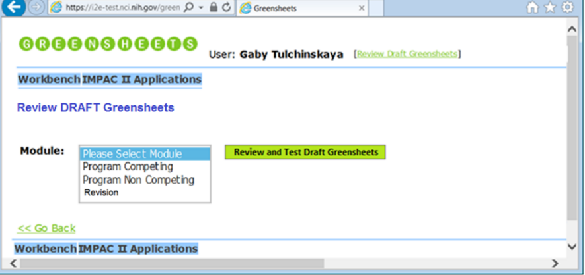

These users (Author/Approver) will have access to the “Review and Test Module” screen (mockup below), where they will have ability to:

* View changes to the module (just view the screen)
* Test any forms
* Select form(s) and send email to testers

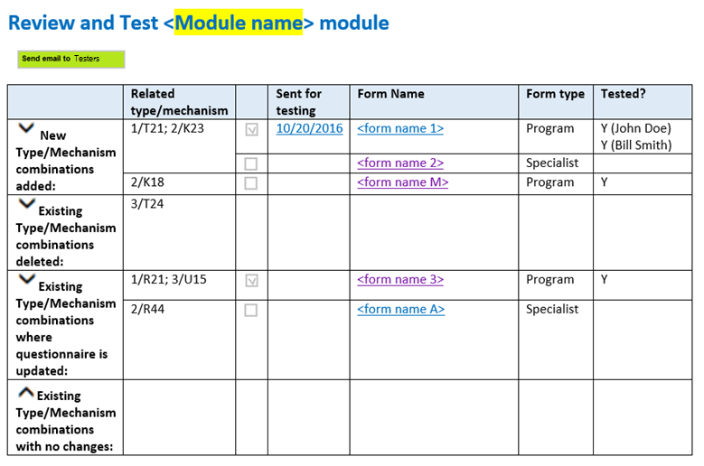

|  |  |  |  |  |  |  |
| --- | --- | --- | --- | --- | --- | --- |
|  | Related type/mechanism |  | Sent for testing | Form Name | Form type | Tested? |
| New Type/Mechanism combinations added: | 1/T21; 2/K23 |  | 10/20/2016 | <form name 1> | Program | Y (John Doe)  Y (Bill Smith) |
|  |  | <form name 2> | Specialist |  |
| 2/K18 |  | 11/01/2016 | <form name M> | Program | Y (Mary Kay) |
| Existing Type/Mechanism combinations deleted: | 3/T24 |  |  |  |  |  |
| Existing Type/Mechanism combinations where questionnaire is updated: | 1/R21; 3/U15 |  | 11/03/2016 | <form name 3> | Program | Y (Brad Pitt) |
| 2/R44 |  |  | <form name A> | Specialist |  |
| Existing Type/Mechanism combinations with no changes: |  |  |  |  |  |  |

Draft Administrator role is still needed. In addition to all functionality, provided to Author/Approver, Draft Administrator will be able to promote/reject module (buttons are displayed only for the user with this role).

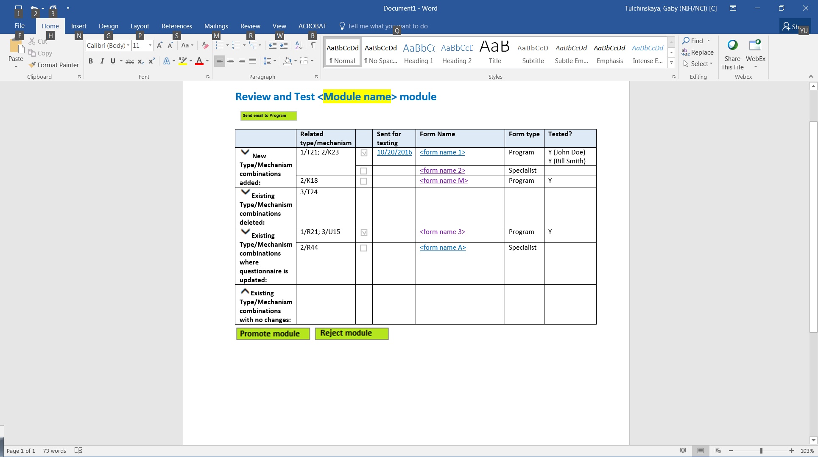

Users, who can access “Review and Test module” screen, will send email to testers. Any user of GS (Program staff or Specialists) can be a Tester. For detailed description of Program and Specialist roles refer to <https://ncisvn.nci.nih.gov/svn/iscs/greensheets/Requirements/Specs/GreenSheets%20Redesign%20Project%20Scope.docx>, sec. GreenSheets users => User roles

The system should NOT impose any restrictions on testing (e.g. Program Director can test Specialist greensheet and Specialist can test Program grrensheet. OGA staff will be responsible for preventing such situations, but no system restrictions are needed.

Tester will receive email with a link, and get access only to greensheet test page (no access to “Review and Test module” screen):

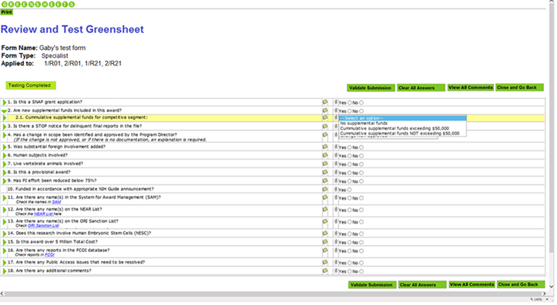

# Diagrams

Please refer to

Sec. Diagrams => User (real person) functionality => Greensheet Testing Functionality

# Overall business flow description

## For a user with Author/Approver and/or Draft Administrator role

User with Author/Approver and/or Draft Administrator role can have access to Draft Area (will have [Review Draft Greensheets] link).

Figure: Access to Draft Area mockup

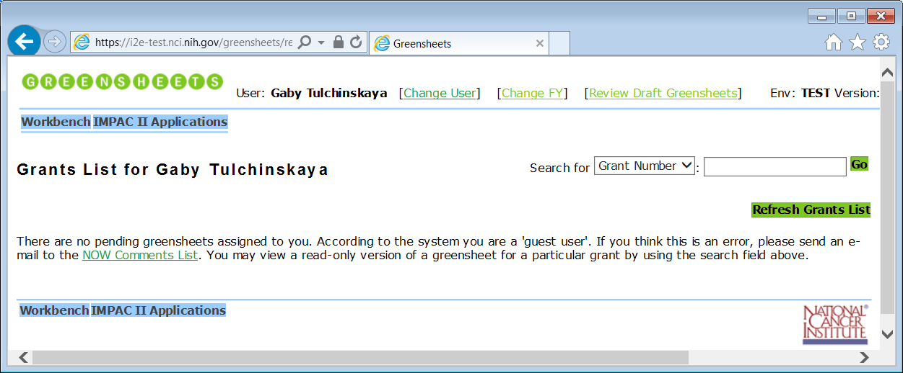

On click, the system displays Review Draft Greensheets screen

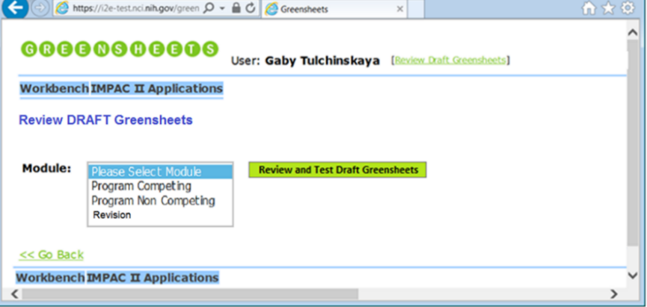

User selects a module and requests to review it (clicks “Review and Test Greensheets” button)

The system displays “Review and Test Module” screen:

Go Back

|  |  |  |  |  |  |  |
| --- | --- | --- | --- | --- | --- | --- |
|  | Related type/mechanism |  | Sent for testing | Form Name | Form type | Tested? |
| New Type/Mechanism combinations added: | 1/T21; 2/K23 |  | 10/20/2016 | <form name 1> | Program | Y (John Doe)  Y (Bill Smith) |
|  |  | <form name 2> | Specialist |  |
| 2/K18 |  | 11/01/2016 | <form name M> | Program | Y (Mary Kay) |
| Existing Type/Mechanism combinations deleted: | 3/T24 |  |  |  |  |  |
| Existing Type/Mechanism combinations where questionnaire is updated: | 1/R21; 3/U15 |  | 11/03/2016 | <form name 3> | Program | Y (Brad Pitt) |
| 2/R44 |  |  | <form name A> | Specialist |  |
| Existing Type/Mechanism combinations with no changes: |  |  |  |  |  |  |

Note: Only user(s) with Draft Admin role (Rob) will have ability to Promote and Reject module (buttons are displayed only for them)



Functionality, provided on Review and Test Module screen:

* Ability to see form type, name and related type/mechs
* Ability to view what changed in the module (type/mechs added/deleted and forms changed)
* Ability to select forms and send email to tester(s), requesting to test selected forms. The system should capture the date when such email has been send
* Ability to see the name of who marked the form as ‘tested’
* Ability to navigate to “Review and Test Greensheet” page for a form
* Ability to promote/reject a module should be provided to Draft Admin only. NOTE: When Draft Admin requests to promote/reject a module, the system should NOT provide a warning, if form(s) are not tested.

Note: Separate “Review and Test module” screen is still need for Revision module. User will send email to a tester who will test revision form.

### Email to testers

When Author/Approver or Draft Admin select form(s) on “Review and Test Module” screen and click “Send email to Testers” button, the system will:

1. Check if Actor selected any checkboxes for the form(s)
   1. If selected checkbox is NOT found, the system will provide an error message: “*Please select at least one form in order to send email to testers*”
   2. If selected checkbox IS found, the system will:
      1. Generate URL(s) to “Review and Test Greensheet” screen for each selected form
      2. Record the date when user clicked “Send email to Testers” button and display it on the screen
      3. Open user’s email client with pre-populated email. Something like:

TO:

**SUBJECT:** Request to test the new greensheet form(s)

**BODY:** Please click:

link to test <New form name 1> - <form type> for <list of related type/mech combination(s)>

link to test <New form name M> - <form type> for <list of related type/mech combination(s)>

and provide a feedback in a separate email to <email of OGA user>

NOTE: OGA will provide a boilerplate.

|  |  |  |  |  |  |  |
| --- | --- | --- | --- | --- | --- | --- |
|  | Related type/mechanism |  | Sent for testing | Form Name | Form type | Tested? |
| New Type/Mechanism combinations added: | 1/T21; 2/K23 |  | 10/20/2016 | <form name 1> | Program | Y (John Doe)  Y (Bill Smith) |
|  |  | <form name 2> | Specialist |  |
| 2/K18 |  | 11/01/2016 | <form name M> | Program | Y (Mary Kay) |

## For a Tester

The system provides ability to test to:

* Author/Approver – accesses testing page by clicking a hyperlinked form name on “Review and Test Module” screen
* Draft Admin – accesses testing page by clicking a hyperlinked form name on “Review and Test Module” screen
* Any Specialist – accesses testing page by clicking a hyperlinked form name in email
* Any Program staff – accesses testing page by clicking a hyperlinked form name in email

When user clicks the link, the system displays Review and Test Greensheet screen:



Functionality, provided on “Review and Test Greensheet” screen:

* Fill the form
* Ability to test submission. Note: all validations on Save are repeated on submission, thus there is no need to have separate Save functionality; if submission test passed, the system should display success message
* Ability to manually mark the form as tested (click “Test Completed” button). No validations are needed for completion of the test. User can never fill the form or submit, the system will still allow mark the form as tested. The system should capture the name of the user, who marked the form as tested
* Clear All Answers
* View All Comments
* User will be able to click URL, it should open in the separate browser window
* “Close” or (if applicable) “Close and Go Back” – user will be taken to a prior screen, where s/he can test other combinations and/or Promote or Reject the module

# Accessing review functionality

## Flow of events

This flow starts when Actor with Author/Approver and/or Draft Administrator role requests to access to Draft Area (will have [Review Draft Greensheets] link).

1. The system displays Review Draft Greensheets screen
2. The system checks if there are module(s) that have been deployed in Form Builder, but not yet processed (promoted or rejected) in Greensheets (draft modules):
   1. If there are NO draft module(s) that have been deployed in Form Builder, but not yet processed (promoted or rejected) in Greensheets, then ‘Module’ dropdown wouldn’t have any values to select from.
   2. If there ARE draft module(s) that have been deployed in Form Builder, but not yet processed (promoted or rejected) in Greensheets, then such modules will be displayed in ‘Module’ dropdown
3. The system provides with ability to:
4. Go Back => in which case Actor navigates to a prior screen (see subsection “Data Specifications” in this section). Use-case ends.
5. Select a module (if any) and requests to review it (clicks “Review and Test Greensheets” button). In this case, Actor is taken to “Review and Test Module screen” for a selected module. Proceed to this document, sec. “Review and Manage Module functionality”

## Mockup



## Data elements

|  |  |  |  |
| --- | --- | --- | --- |
| Element Name | Description | Element Type | Comments |
| Review Draft Greensheets | Screen title | Read-only |  |
| Module | Allows selecting a module (if any) that have been deployed in Form Builder, but not yet processed (promoted or rejected) in Greensheets | Dropdown |  |
| Review and Test Draft Greensheets | Allows to navigate to Review and Test Module screen for a selected module | Button | UI should provide an intuitive solution for situation when there are no modules in the dropdown and user cannot click “Review and Test Draft Greensheets” button |
| Go Back | Allows navigation back to initial screen, e.g. if Author/Approver is also a Specialist, when s/he could possible click Review Draft Greensheet link on Grants list screen for Specialist. Go Back link will allow to navigate back to Grants list screen for Specialist | Navigation link |  |

# Review and Manage Module functionality

## “Review and Manage Module” flow of events

1. The system displays Review and Manage Module screen for a selected module
   1. If this is a Revision module, then refer to sec. Review and Manage Module screens mockups => Revision module mockup
   2. If this is any module, except Revision, then refer to sec. Review and Manage Module screens mockups => “General mockup for all modules, except Revision” and “Existing Type/Mechanism combinations with no changes” section mockup”
2. The system provides with ability to:
   1. Go Back to Review Draft Greensheets screen
   2. Ability to select forms and send email to tester(s), requesting to test selected forms. The system should capture the date when such email has been send. For details see this document, sec. Overall business flow description => For user with Author/Approver or Draft Administrator role => Email to testers
   3. Ability to navigate to “Review and Test Greensheet” page for a form. If Actor selects this option, refer to this document, sec. “Test Greensheet functionality”
   4. Ability to promote/reject a module should be provided to Draft Admin only. NOTE: When Draft Admin requests to promote/reject a module, the system should NOT provide a warning, if form(s) are not tested. For details see this document, sec. Promote or Reject the module functionality
3. Actor performs one of actions above. Use-case ends.

## Review and Manage Module screens mockups

### General mockup for all modules, except Revision

Go Back

|  |  |  |  |  |  |  |
| --- | --- | --- | --- | --- | --- | --- |
|  | Related type/mechanism |  | Sent for testing | Form Name | Form type | Tested? |
| New Type/Mechanism combinations added: | 1/T21; 2/K23 |  | 10/20/2016 | <form name 1> | Program | Y (John Doe)  Y (Bill Smith) |
|  |  | <form name 2> | Specialist |  |
| 2/K18 |  | 11/01/2016 | <form name M> | Program | Y (Mary Kay) |
| Existing Type/Mechanism combinations deleted: | 3/T24 |  |  |  |  |  |
| Existing Type/Mechanism combinations where questionnaire is updated: | 1/R21; 3/U15 |  | 11/03/2016 | <form name 3> | Program | Y (Brad Pitt) |
| 2/R44 |  |  | <form name A> | Specialist |  |
| Existing Type/Mechanism combinations with no changes: |  |  |  |  |  |  |



### “Existing Type/Mechanism combinations with no changes” section mockup

When expanded:

|  |  |  |  |  |  |  |
| --- | --- | --- | --- | --- | --- | --- |
| Existing Type/Mechanism combinations with no changes: | 5/R21; 5/U15 |  |  | <form name 3> | Program |  |
| 5/R44 |  |  | <form name A> | Specialist |  |

### Revision module mockup

Review and Test Revision Module

Go Back

|  |  |  |  |  |  |  |
| --- | --- | --- | --- | --- | --- | --- |
|  | Related type/mechanism |  | Sent for testing | Form Name | Form type | Tested? |
| Revision Greesheet Form: | All/All |  | 10/20/2016 | <Revision form> | Revision | Y (John Doe)  Y (Bill Smith) |



## Review and Test Module Screen Data elements

|  |  |  |  |
| --- | --- | --- | --- |
| Element Name | Description | Element Type | Comments |
| Review and Test <insert module name> Module | Screen title | Read-only |  |
| Go Back | Allows to return back to Review Draft Greensheets screen | Navigation link |  |
| Send email to Testers | See this doc., sec. Overall business flow description => For user with Author/Approver or Draft Administrator role => Email to testers | Button |  |
| Section | Values:   * New type/mechanism combinations added ---expanded by default, not displayed for Revision module * Existing type/mechanism combinations deleted ---expanded by default, not displayed for Revision module * Existing type/mechanism combinations where questionnaire is updated---expanded by default, not displayed for Revision module * Existing type/mechanism combinations with no changes---collapsed by default, not displayed for Revision module * Revision Greensheet Form ---applicable to the screen for Revision module only, expanded by default | Read-only label | Expandable/collapsible |
| Related type/mechanism | Set of Application type/Application mechanism combinations, related to this form in Form Builder | Read-only |  |
| Select | Allows to select form(s) for which email should be send to testers | Checkbox | Not displayed in sections:  “Existing type/mechanism combinations deleted”  And  “Existing type/mechanism combinations with no changes” |
| Sent for testing | Date when Actor selected the checkbox for this form and clicked “Send email to Testers” button | Read-only | Format MM/DD/YYYY |
| Form Name | New form name, exported from Form Builder | Hyperlink or read-only | * Not displayed in section “Existing type/mechanism combinations deleted” * Read-only in section “Existing type/mechanism combinations with no changes” |
| Form Type | Possible values:   * Program * Specialist * Revision | Read-only | Not displayed in sections:  “Existing type/mechanism combinations deleted” |
| Tested? | Possible values:   * Blank * Y   For each tested form (“Y” value is displayed), the system should display the name of the user, who marked the form as tested | Read-only | Not displayed in sections:  “Existing type/mechanism combinations deleted”  And  “Existing type/mechanism combinations with no changes” |
| Promote Module | Allow promoting this module | Button | Provided only to a user with Draft Admin role |
| Reject Module | Allow rejecting this module | Button | Provided only to a user with Draft Admin role |
| Go Back | Allows navigation to a previous page | Navigation hyperlink |  |

# Test Greensheet functionality

## “Test” flow of events

Actor navigates to Review and Test Greensheet page

* Fill the form
* Ability to test submission. Note: all validations on Save are repeated on submission, thus there is no need to have separate Save functionality; if submission test passed, the system should display success message
* Ability to manually mark the form as tested (click “Test Completed” button). No validations are needed for completion of the test. User can never fill the form or submit, the system will still allow mark the form as tested. The system should capture the name of the user, who marked the form as tested
* Clear All Answers
* View All Comments
* User will be able to click URL, it should open in the separate browser window
* “Close” or (if applicable) “Close and Go Back” – user will be taken to a prior screen, where s/he can test other combinations and/or Promote or Reject the module

## Review and Test Greensheet Screen mockup



## Sub-questions

Currently (in preview mode) after promoting from Form Builder the system display a question number as follow:

Question #6 with option Yes and No

Question #6.1 – related to Yes answer on #6

Question #6.2 – related to Yes answer on #6

Question #6.1 – related to No answer on #6

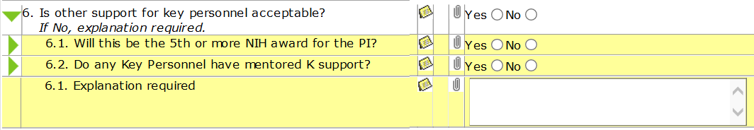

## Review and Test Greensheet Screen Data elements

|  |  |  |  |
| --- | --- | --- | --- |
| Element Name | Description | Element Type | Comments |
| Review and Test Greensheet | Screen title | Read-only |  |
| Header section: | | | |
| Form Name | Displays form name that is exported from Form Builder | Read-only |  |
| Form Type | Displays form type | Read-only | Possible values:   * Program * Specialist * Revision |
| Applied to | Displays the list of type/mech combinations for which this form is used | Read-only |  |
| Buttons on the screen (could be repeated above and below a questionnaire) | | | |
| Print |  | Button |  |
| Testing Completed | Allows to mark the form as ‘tested’. | Button | The system should save the name of the user, who marked the form as tested. |
| Validate Submission | Allows to run all validations on submission. | Button | For the list of validations, please refer to <https://ncisvn.nci.nih.gov/svn/iscs/greensheets/Requirements/Use-cases/View%20and%20Manage%20a%20greensheet%20use-case.doc>  Sec. Alternative flows => Edit and Save a greensheet => *Validations on Save*  Sec. Alternative flows => Submit a greensheet => “Overall validations on Submit” and “Validations on Submit for individual questions”  Note: validations on submission should include all validations on Save |
| Clear All Answers | Allows to clear all answers | Button | Refer to <https://ncisvn.nci.nih.gov/svn/iscs/greensheets/Requirements/Use-cases/View%20and%20Manage%20a%20greensheet%20use-case.doc>  Sec. Alternative flows => Edit and Save a greensheet => Clear All Answers |
| View All Comments | Allows to view all comments | Button | For description of elements, please refer to <https://ncisvn.nci.nih.gov/svn/iscs/greensheets/Requirements/Use-cases/View%20and%20Manage%20a%20greensheet%20use-case.doc>  Sec. USER INTERFACE => UI elements and rules =>   * View All Comments button * View/Hide All Comments button * View All Comments functionality * Hide All Comments functionality |
| Close | Allows to close the page | Button | Displayed to a Tester (Program or Specialist) who clicked on the link in email |
| Close and Go Back | Allows to navigate back to Review and Test Module screen | Button | Displayed only to Author/Approver and Draft Admin |
| Questionnaire portion of the screen | | | |
| For description of elements, please refer to <https://ncisvn.nci.nih.gov/svn/iscs/greensheets/Requirements/Use-cases/View%20and%20Manage%20a%20greensheet%20use-case.doc>  Sec. USER INTERFACE => UI elements and rules => SR0030-010-09 (Questionnaire) | | | |

# Promote or Reject the module functionality

1. Actor requests to Promote or Reject the module
2. The system:
   * Displays correcponding warning

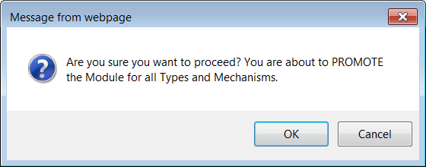

or

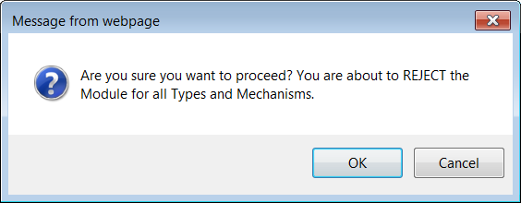

If user clicks OK, the system:

* Promotes/rejects a module
* Saves the date when a module has been promoted/rejected
* Sends email. See this document, sec. “Email Notifications about greensheets module deployment process”.
* Returns user to the Review Draft Greensheet screen. When user returned to this screen, the system checks if any unprocessed module left:
* If there are no more unprocessed modules, then the system displays a version of the screen with no modules to select from
* If at least one unprocessed module left, the system displays a version of the screen with selected unprocessed module

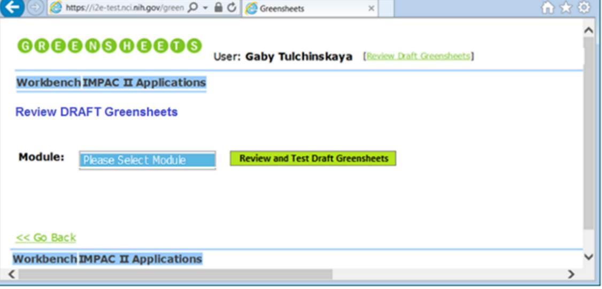

# Import templates from GS Form Builder

Specific templates for each module are created and approved in Form Builder. After exporting a module from Form Builder the system parse and creates “draft” templates for review and processing by the user.

|  |  |  |
| --- | --- | --- |
| Reference | Rule name | Description |
| SR0070-010 | Parsing Questions Definition source files | System will be able to parse, and interpret for the purpose of extracting forms with elements, questions, and possible answers, source files with question definitions that meet the following conditions.   1. Source files with question definitions will be stored as regular ASCII text files, editable with any plain-text editor. 2. System will allow for question definitions to be stored in five separate such files – one each for questions applicable to:            i) Program greensheets for competing grants,          ii) Program greensheets for non-competing grants,          iii) Specialist greensheets for competing grants,          iv) Specialist greensheets for non-competing grants  v) Revision greenshets,  3.   The content of the files will be represented as well-formed and valid XML. Precise definition of elements, attributes, and other components of the XML schema is left to determination by the technical team as a part of analysis and design activities. However, the XML schema adopted will support the following requirements:         a)  Each question can be marked as required to appear on greensheet forms for grants of more than one type/mechanism. Each type/mechanism combination to which the form is applicable will be specified individually.         b)  Each question definition will include the possible type of response value, which can be any of the following:   * Multi-line text field * File attachment * Text string * Number * Date * Answer options to be shown as a drop-down list * Answer options to be shown as "radio buttons" * Answer options to be shown as check boxes (selecting multiple answer options possible).        c)  When response type is answer options, question definition will include the exact list of those options.       d)  Each question can have "nested" sub-questions. Sub-questions can be associated with specific answer option being chosen for their parent question. (In other words, a sub-question "Was certificate received from grantee organization?" can be associated only with the answer option "Yes" to the parent question "Is a certificate XYZ required?", but not with answer option "No".)      e) Sub-questions will have all the same attributes in the definition file as top-level questions. |
| SR0070-020 | Output files and database storage | 1. System will save the received XML file from the Form Builder in a backup directory marked with timestamp 2. System will store a greensheet form template for a grant of multiple type/mechanism combinations on a separate row in the database. 3. Reports that the system will produce concerning the questions defined in Question Definition Source files (the XML files) are for internal use of the Development team. Their purpose is to assist the IT professionals maintaining the Greensheets system in validating the XML files and ensuring their quality and accuracy as they try to configure which questions will be asked on greensheet questionnaires for grant of which types/mechanisms.  Business owners and other stakeholders provided no requirements with respect to these reports. Therefore, their content and format are up to the Development team |
| SR0070-030 | Error Handling | 1. YP: I don’t think we need a Forms Generator as a stand-alone utility since we are using GSFB |
|  | Passing validations to individual questions from Form Builder to Greensheets | Parent question might have a sub-question.  There is ‘Edit Skips’ functionality in Form Builder (used during editing a question) that determines if sub-questions are displayed in a greensheet, depending on the answer to the immediate previous question (not necessarily a parent question).  This relationship is reflected in XML.  (Related to sec. “Submit greensheet”) |
|  | Active URL | Refer to Greensheet-560 - URL on Form Builder questsion must be active in GreenSheets system  When URL is entered in FB question and the form is exported into GreenSheets, this link must be active |
|  | No defaults | Refer to Greensheet-519 and Greensheet-559  When XML file is processed, the system should ignore any defaults to the answers.  Requirements: <https://ncisvn.nci.nih.gov/svn/iscs/greensheets/Requirements/Specs/GreenSheets%20Redesign%20Project%20Scope.docx>; Sec. Form Builder – changes for re-design |

# Email Notifications about greensheets module deployment process.

A notification email will be sent to users each time an action in the deployment process is executed per the table below.

|  |  |  |  |  |
| --- | --- | --- | --- | --- |
| Triggering event | To | Which system sends this email? | Subject line | Body: |
| Module was successfully imported into GS | The recipient list for all GS messages is set in a property file.  It is not dynamically generated in the code.  To: Looks like NCI_NOW_L | GS | [GS - TEST 2017-02-09 11:19:16 AM] Confirmation of Successful Import of Draft Greensheets | Thank you for your request. The <Insert module name> Draft Greensheets Forms are available for you to review. Please log into the Greensheets Application using the URL given below and select this module in the Review DRAFT Greensheets screen to review and test Greensheets Forms of the module.    Comments for <Module Name> import:  <Insert comments, entered in Form Builder>    Greensheets Application URL: <https://i2e-test.nci.nih.gov/greensheets/>   (URL should be customized to open GS page with imported draft module |
| Unsuccessful Import of the module into GS | The recipient list for all GS messages is set in a property file.  It is not dynamically generated in the code. | GS | Unsuccessful Import of the DRAFT Greensheets | Thank you for your request. The request did not go through and it resulted in errors. Please contact the System administrator for assistance. |
| Module is successfully promoted into production area of GS | The recipient list for all GS messages is set in a property file.  It is not dynamically generated in the code.  To: Looks like NCI_NOW_L | GS | [GS - TEST 2017-02-09 10:37:29 AM] Confirmation of Successful Promotion of Draft Greensheets | The <Insert module name> Draft Greensheets are successfully promoted to Production.    Greensheets Application URL: <https://i2e-test.nci.nih.gov/greensheets/> |
| Module is rejected in DRAFT area in GS | The recipient list for all GS messages is set in a property file.  It is not dynamically generated in the code.  To: Looks like NCI_NOW_L | GS | [GS - TEST 2017-02-09 04:47:56 PM] Rejection of the Draft Greensheets | The <Insert module name> Draft Greensheets were rejected.  Greensheets Application URL: <https://i2e-test.nci.nih.gov/greensheets/> |

Reverse re-engineering notes:

* 1. GS emails are being sent by ProcessNewQuestionDefsServiceImpl. In addition, there is a property called gs_send_mail defined in greensheetconfig.properties that can be used to disable email sending (setting its value to false). The messages are being sent to the list of addresses defined in the gs_error_email_to property in greensheetconfig.properties
  2. Question: if we are sending this email, why we are not capturing rejection event and date in FB (OGA asked for this info multiple times)?

Answer:  GS does not have a “back link” to GSFB, therefore, Form Builder cannot get the promote or reject event from GS.  It is doable but is required design and resources.